Experiment 7
CREATE TABLE BANK (
BANKNAME VARCHAR2(50),
HEADOFFICE VARCHAR2(50),
BRANCH VARCHAR2(50),
BRANCHCODE INT
);
INSERT INTO BANK VALUES ('KGB','Kochi','Pala',137);
INSERT INTO BANK VALUES ('SIB','Mumbai','Kozhuvanal',1430);
INSERT INTO BANK VALUES ('SBI','Delhi','Kochi',125);
INSERT INTO BANK VALUES ('AXB','Punjab','Chennai',123);
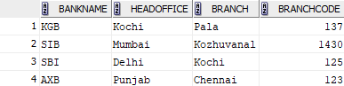
COMMIT
INSERT INTO BANK VALUES ('HDFC','Karnataka','Malappuram',567);
COMMIT;

SELECT * FROM BANK;
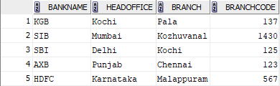

SAVEPOINT
INSERT INTO BANK VALUES ('FDB','Goa','Kollam',490);
SAVEPOINT A;

SELECT * FROM BANK;
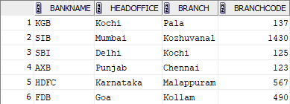
INSERT INTO BANK VALUES ('Canara','Canada','Kottayam',2389);
SAVEPOINT B;
SELECT * FROM BANK;
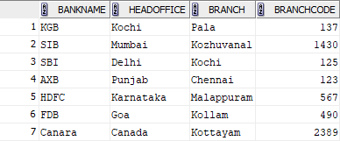

ROLLBACK
ROLLBACK TO B;
SELECT * FROM BANK;
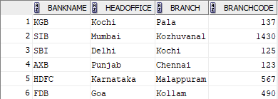
GRANT
GRANT SELECT ON BANK TO c24csa27;
SELECT * FROM c24csa27.BANK;
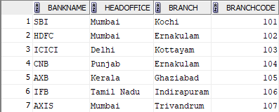
REVOKE
REVOKE SELECT ON BANK FROM c24csa27;

